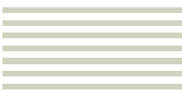



*Toad Data Modeler Guide by John Cusey*

*January 13, 2019*

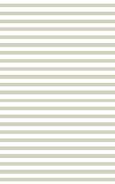

Contents

2 Introduction 3

3 Setting up Project 3

3.1 How to create a project 3

4 Building the model 4

4.1.1 How to create a model 4

4.1.2 Adding an Entities 5

4.1.3 Add Foreign Key 8

5 Exporting and Importing Files 8

6 Grouping entity together 8

7 Generating DDL Script 10

# Introduction

https://www.quest.com/products/toad-data-modeler/

Easily create high-quality data models. Toad Data Modeler enables you to rapidly deploy accurate changes to data structures across more than 20 different platforms. It allows you to construct logical and physical data models, compare and synchronize models, quickly generate complex SQL/DDL, create and modify scripts, as well as reverse and forward engineer both databases and data warehouse systems. Toad's data modeling software simplifies database design, maintenance, and documentation.

# Setting up Project

## How to create a project

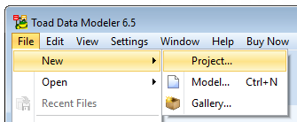

Creating a New Project

A project is a container that holds all of your physical elements like entities, relationships, and views. When you create a new model, then you’ll see the Physical Model Explorer appear at the vertical left-hand-side of this tool.

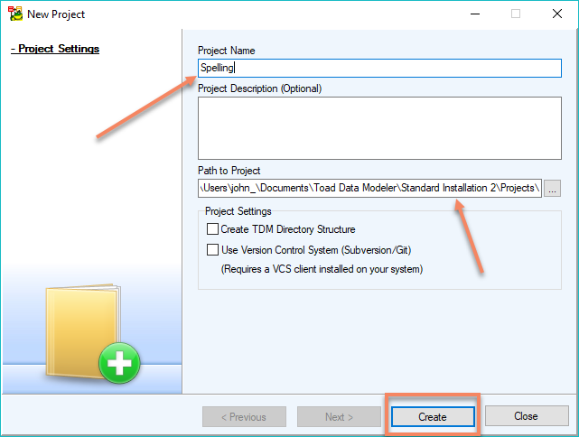

Assign Project Name

When creating a new project, you will have to specify the project name, the path to the project and project settings. In the project path, you’ll notice part of the path I have a “standard insulation 2” this is because I initially installed the wrong version of TDM and had to reinstall the software. The freeware version of TDM is 6.5.5.

C:\Users\john_\Documents\Toad Data Modeler\Standard Installation 2\Projects\

# Building the model

### How to create a model

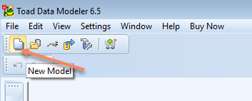

Creating a New Model

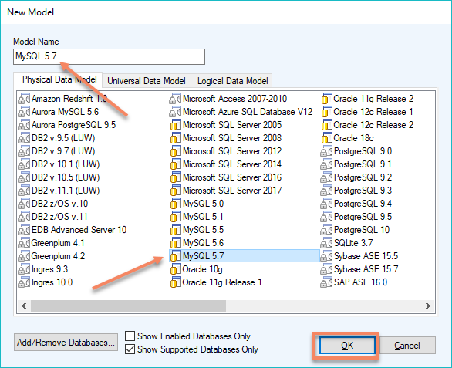

Assigning a model name and database type

### Adding an Entities

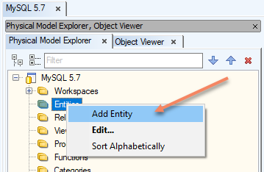

Adding Entity

***Right click*** on the Entities Folder in the Physical Model Explorer to select the add ***entity option***.

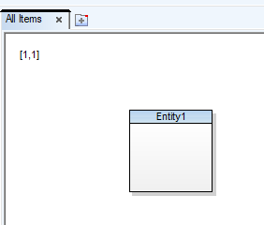

Empty entity

An empty entity will appear in your workspace. You have to ***double click*** the entity to open the Entity Property dialog box so you can assign the entity a name and add attributes.

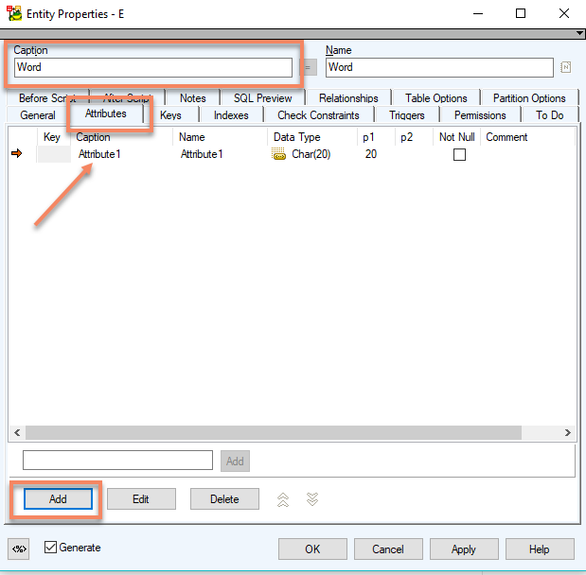

Assign Entity Properties

I typed in the ***Caption Box*** to assign ***“Word”*** as the name of this entity. Then clicked on the Attribute Tab to show the Attribute Table. Just click on the ***Add Button*** at the bottom of the dialog box to add an entity to the Entity Table.

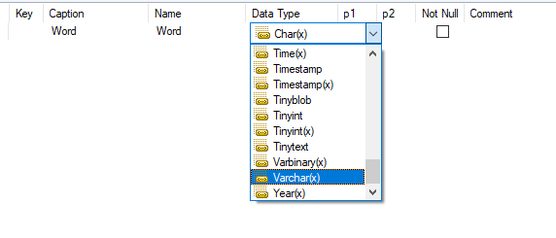

Changing attributes

Just single click on the ***Attribute Row*** in the table you want a change that row.

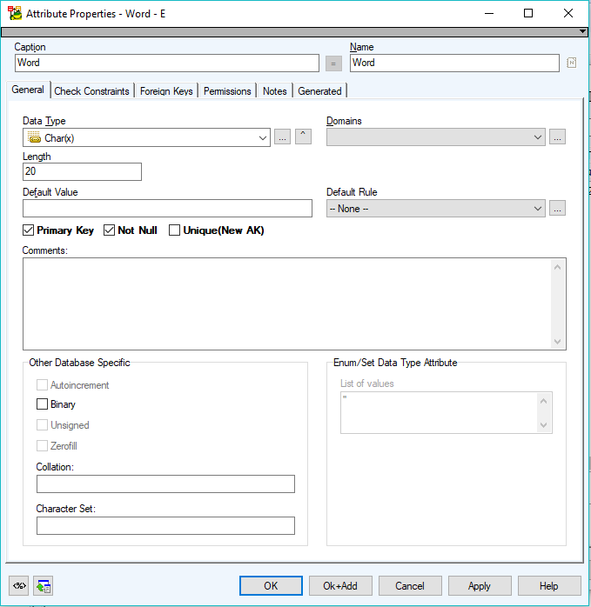

Double click open Attribute Properties

You can ***double click*** on the Attribute Row to open up the Attribute Properties Dialog Box to set this row is the Primary Key.

### Add Foreign Key

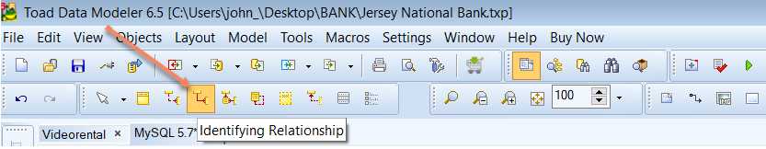

Identifying Relationship

Pick the relationship between the two entities. Click on one entity then click on the other entity which you what makes the relationship.

*Relationship strength* is derived on how the primary key of a related entity is defined. A weak, or non-identifying, a relationship exists if the primary key of the related entity does not contain a primary key component of the parent entity.

A strong, or identifying, a relationship exists when the primary key of the related entity contains the primary key component of the parent entity.

# Exporting and Importing Files

To start exporting and importing files with Toad Data Modeler, you have to go to the main menu and select ***Files → Import*** or ***Files → Export*** to import and export files.

# Grouping entity together

To help organize you can put tables together into a category of tables and assigning them mutual color. I have taken any table containing data about the bank branch into one table group. This table category contains the employees who work at that branch and the hours the branch. The other categories I used are ways the customer can provide interaction with the branch, customer information, and bank branch details. When I add a new table to this model, I will determine what table grouping the table data should go.

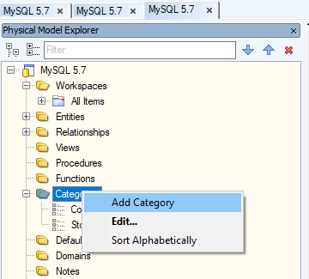

Add Category Name

Then you need to select the color you want to assign to this table category.

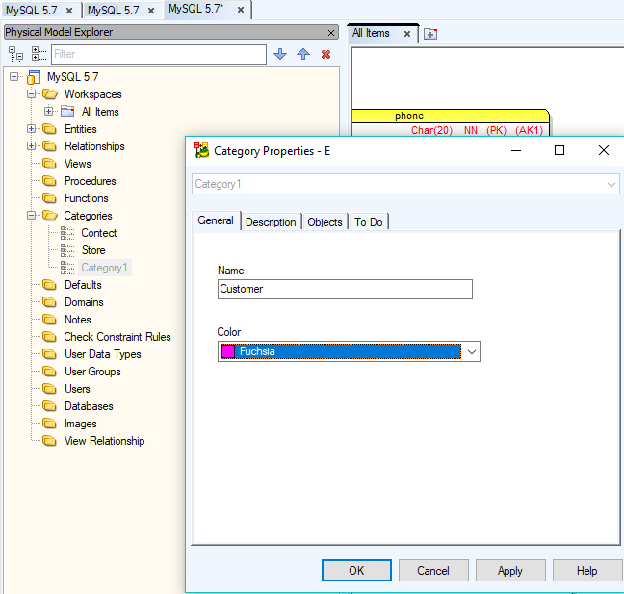

Name and Color the Category

When having the Category Properties Dialog Box open, you can assign which table you want to put in this table category. This option is under the objects tab.

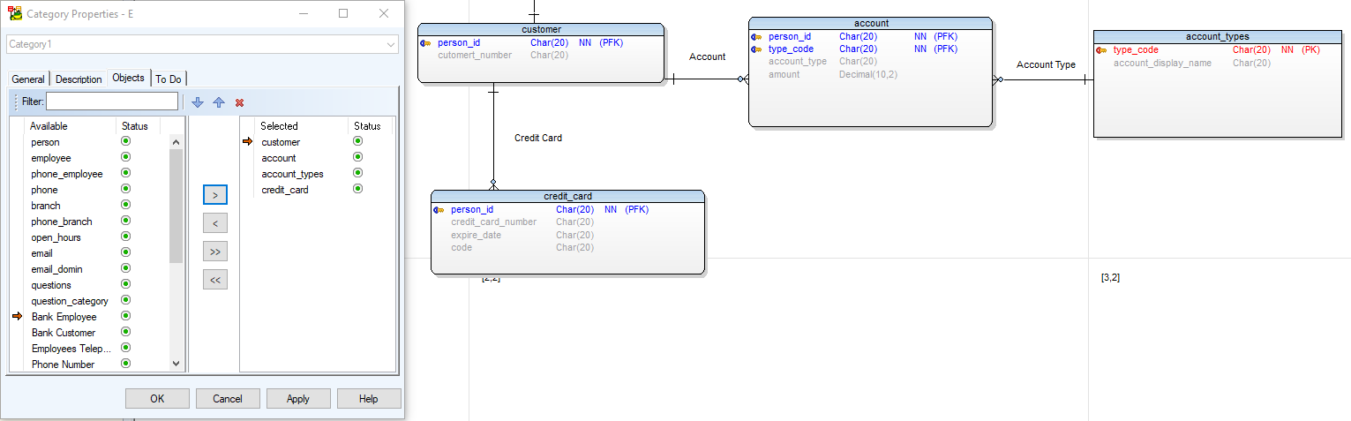

Adding Objects to Category

# Generating DDL Script

DDL (Data Definition Language) is a language used by a database management system that allows users to define the database and specify data types, structures and constraints on the data. Examples DDL statements are: CREATE TABLE, CREATE INDEX, ALTER, and DROP.

From the main menu select ***Model → Generate DDL Script*** then click the ***Generate Button*** at the bottom of the window.

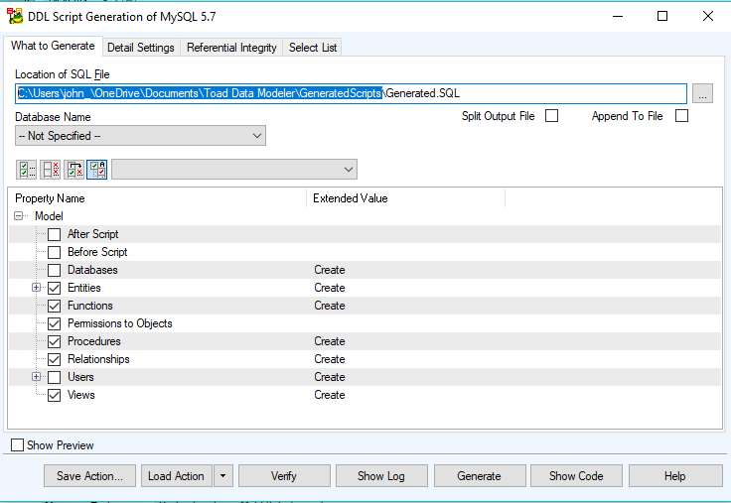

Generating DDL Script